Intelligent Traffic Information System Based on Internet of Things

Iram Ahmed Dhrubo, Rizwan Mohammad Chowdhury and Sumaiya Akter Nitu  
*Fab Lab IUB*  
*Independent University, Bangladesh*Dhaka, Bangladesh  
Email: iramdhrubo31@gmail.com; rizwanchowdhury64@gmail.com; sumaiyaakternitu924@gmail.com

***Abstract*— In this day and age, traffic has turned out to be a major problem in most cities, making people's lives really difficult. Dealing with heavy traffic can cause serious physical and psychological problems, including stress and aggression. A survey by the Passengers Welfare Association found that at least 87% of buses and minibuses violate traffic rules. Around 74 people are losing their lives and another 150 are injured every day across the country and apart from the pain and suffering, road accidents have a significant economic and social cost that is not easily quantified in monetary terms. So, we decided to make a IOT Based traffic monitoring system to overcome the problem and will focus on the designing and developing a real-time traffic monitoring system using the Internet of Things. This paper focuses on monitoring number of vehicles stuck in heavy traffic, the air pollution as well as sound pollution. This system will also display the data as well as the live footage of traffic.**

***Keywords***—***NodeMCU, IoT based System, Traffic, Vehicles, Air Sensor, Sound Sensor, Information System, Live feed.***

1. Introduction

The Radio Frequency Identification (RFID) played a huge role in the development of field of traffic management being around for about 50 years. This method allows user friendly and cost-efficient solutions. RFID can also be used in vehicle detection, identification, security, tracking, and parking management. Traffic congestion in roads throughout the world, especially during rush hour, continues to be a major problem plaguing the citizens, builders, planners and officials. This impacts the environment by affecting the air via air pollution, fuel combustion and road rages resulting in noise. IoT is a network of interconnected devices made up of sensors, network connectivity and software. By collecting and exchanging data, such interconnections make it possible for the sensors to be responsive. An IoT system-based sensor plays important roles by measuring physical and environmental factors and convert them to electric signals. [1]

Different sensors are required for different functions and applications. Present-day transport systems continue to unsuccessful in providing smooth transportation to citizens in the world of uninterrupted and rapid development. This unfortunately leads to unnecessary traffic jams which delay professional and personal spots. In addition, this also arise problems such as mental frustration causing road rages, fuel wastage, and wear and tear of vehicles. [2] Today, this traffic jam is faced by everyone due to the increase in road vehicles. IoT can be used to solve the traffic problems. This can be done by using multiple types of sensors to measure the density of traffic, dumped areas and congested roads alerting the drivers so that they can avoid them. [2]

Another prominent system in this regard is the Traffic Management System (TMS). which addresses urban congestion issues. The traffic lights also play an important role by decreasing traffic accidents and ease the traffic congestion with proper coordination. The first manually operated traffic light was invented by John Peake Knight in 1868, and first automated traffic light was invented by Lester Farnsworth Wire in 1912. [3]

Previously, Static TLS were more widely used than Dynamic TLS in the traffic management, which was inefficient due to increased traffic density and congestion. This can be solved by using Dynamic TLS which adapts the traffic pattern based on the vehicle numbers at the moment. [1]

Besides the traditional traffic control systems, new technologies in wireless communication, control systems, image processing, and data mining have adapted with the current transportation and street structures which implies the next level of smart and intelligent facilities known as Intelligent Transportation Systems (ITS). Recently, further development in the field of communication has also emerged new area known as Internet of Things (IoT) which has gained special interest both in academia and industry due to the diverse platform that can be connected together and communicate with each other under this paradigm. [4]

This paper highlights optimization of the traffic data collected in a city using sensor modules. This paper provides configuration which minimizes the possibilities of traffic problems. Due to this proposed system of Intelligent Traffic, data collection is more efficient and convenient. Identification of heavy traffic areas is done successfully and swiftly. The data collected can be easily analyzed and then can be used to study about the traffic and the problems can be easily minimized. Hence, both the precious lives as well as time would be saved. The proposed system can provide a new way of monitoring traffic flow which helps in improving traffic conditions and resource utilization.[6]

1. Proposed System Topology

In our day-to-day busy life, there is an enormous increase in the number of vehicles in the streets since we often prefer to use a vehicle for transportation instead of walking. In our proposed methodology, we create a system where we are able to monitor the traffic in the streets, then give the statistical data of the number of vehicles stuck in traffic. In addition, the system also consists of sensors which will detect the quality of air as well as the quality of sound in the surrounding.[7]

The components for this methodology are:

1. NodeMCU Module

2. ESP 32 Cam Wi-Fi + Bluetooth Camera Module

3. MQ135 Air Quality Sensor Module

4. Sound Sensor Module

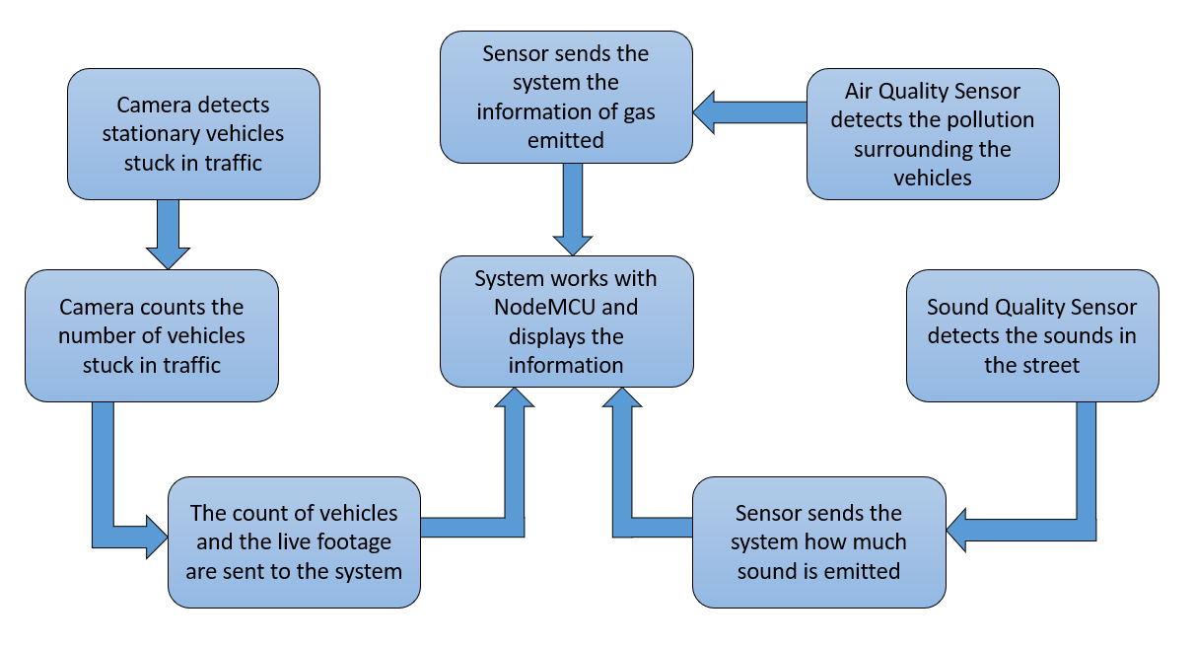

1. Block diagram of the methodology of the proposed system

Firstly, we will detect each vehicle by using a web camera, which will give us a live feed to help us monitor the vehicle while stuck in traffic. When the vehicles are stuck in traffic, the vehicles stuck in a traffic lane will be recorded by the web camera and it will show the vehicles which will be stuck in traffic and this will change depending on the vehicles that are stationary and visible on the camera’s field of vision. If there is no traffic, the vehicles will not be stationary and the live feed will show the vehicles that are stationary.

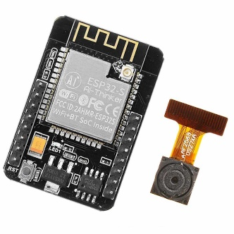

1. The image of ESP32 CAM Wi-Fi + Bluetooth Camera Module

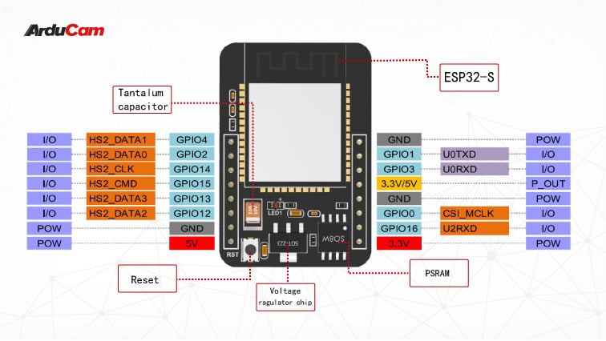

1. The structure of ESP32 CAM Wi-Fi + Bluetooth Camera Module along with pin names

The fingerprint is scanned in the first step. The second Secondly, we will use a MQ135 Air Quality Sensor Module which will detect air pollution in the surrounding. This module is basically a gas detector and it will provide information of the air quality surrounding the vehicles. In this demonstration, we will be using the gas sensor to measure smoke emitted from vehicles and the amount of carbon dioxide, carbon monoxide and other gases emitted from the gas. So, when the gas detector senses the gas, it will send the amount of a particular gas to the information system, where the system will show the statistics of gas present in air.

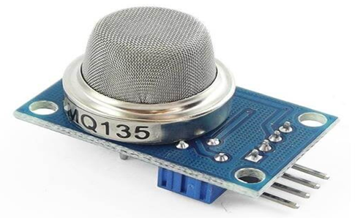

1. The image of the MQ135 Air Quality Sensor Module

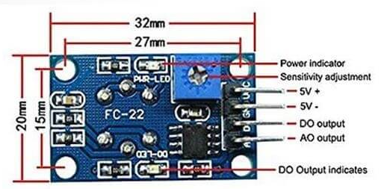

1. The labelled diagram of the MQ135 Air Quality Sensor Module

Thirdly, we will use a Sound Sensor Module to measure the sound in the streets. For instance, this module can measure the sound of horns of cars and busses. The information will help us to determine how much sound pollution occurs in an area. The data originated from this sensor will be sent to the information system, and once the system receives the data, it will preview the amount of sound pollution in a specific atmosphere.

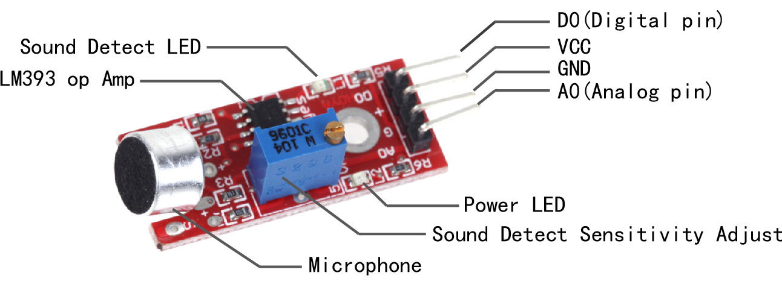

1. The image of the Sound Sensor Module

Lastly, we will use NodeMCU which is an open-source platform that allows us to connect objects and transfer data using Wi-Fi protocol. This platform will help us connect all the aforementioned components with IoT and then transfer the data and work accordingly.

|  |  |  |
| --- | --- | --- |
|  |  | (1) |

In this system, we will also use breadboard and jumper wires with NodeMCU to connect with the sensors and camera module.

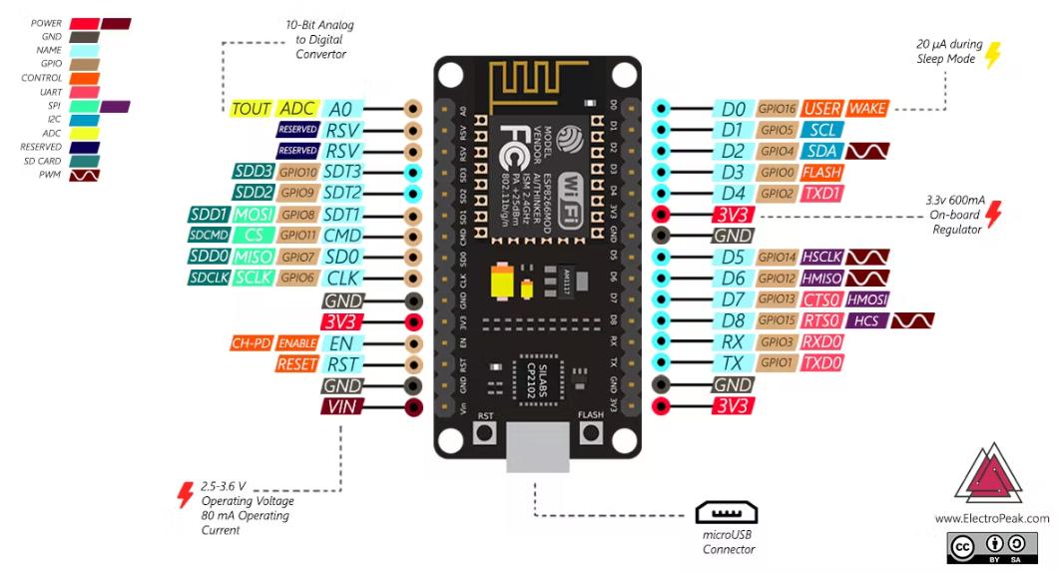

1. The image NodeMCU along with each pin names

The current system uses NodeMCU which will allow us to connect with IoT and then we can view the data by connecting the NodeMCU with a laptop or PC. We will use micro-USB connector to connect the NodeMCU module with the device.

1. Proposed System Design and Simulation

The system is constructed in a small box, inside which the circuit board is set up. Once the system is ready, it will be placed in a specific place where it will be able to monitor and the send the data to a smartphone or laptop via internet.

The system is constructed in a small box, inside which the circuit board is set up. Once the system is ready, it will be placed in a specific place where it will be able to monitor and the send the data to a smartphone or laptop via internet.

Using a NodeMCU and the ESP32 Camera Module, the system works perfectly. Since this project is a prototype, this system is used to detect human. Initially, Camera Module detects human and shows the live feed.

Apart from that, the system also has a gas sensor and sound sensor. The data collected from the sound sensor is displayed in a website called ThinkSpeak. The data are previewed in a graphical form, which also shows the number of entries. The time delay to display the data is 15 seconds.

The gas sensor also works in a similar way as the sound sensor. The data collected from the gas sensor is also displayed in ThinkSpeak. The data are previewed in a graphical form, which also shows the number of entries. The time delay to display the data is also 15 seconds.

The gas sensor also works in a similar way as the sound sensor. The data collected from the gas sensor is also displayed in ThinkSpeak. The data are previewed in a graphical form, which also shows the number of entries. The time delay to display the data is also 15 seconds.

When all the components are compiled together, the online simulation is done in a simulation software called circuito.io, where all the components are all connected as shown in Fig. 8. Resistors are also used to limit the flow of excessive current throughout the circuit.

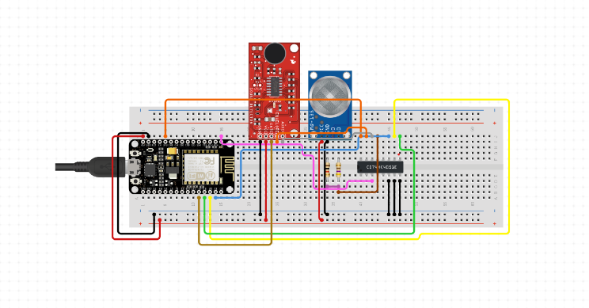

1. The simulation of the Intelligent Traffic Information System

For the project’s external system, the components are placed in such a manner that only the parts of the sensors and camera that are useful are visible. As for the internal system, the wires that are required in the system are placed inside the box. Unlike other components, NodeMCU is placed inside the box. However, the MicroUSB port of NodeMCU is visible so that it can be connected with other device in order to run the code.

1. Hardware Development and Testing

The Traffic Monitoring System can be operated through a smartphone through Wi-Fi. We first connect the NodeMCU Module with the gas sensor, then with the sound sensor and finally with the camera module.

The MQ135 Gas Sensor is connected with the NodeMCU in the following manner:

a) The VCC pin of the gas sensor is connected with the 3V pin of the NodeMCU.

b) The Ground pin of the gas sensor is connected with the 3V pin of the NodeMCU.

c) The Output A0 pin of the gas sensor is connected with the A0 pin of the NodeMCU.

The Sound Sensor module is connected with the NodeMCU in the following manner:

a) The VCC pin of the sound sensor is connected with the 3V pin of the NodeMCU.

b) The Ground pin of the sound sensor is connected with the ground pin of the NodeMCU.

c) The Output A0 pin of the sound sensor is connected with the A0 pin of the NodeMCU.

The ESP32 Camera Module is connected with the NodeMCU in the following manner:

a) A Ground pin of the camera module is connected with a ground pin of the NodeMCU.

b) The second Ground pin of the camera module is connected with the 100 pin of the same camera module.

c) The EN pin of the NodeMCU module is connected with the ground pin of the same NodeMCU.

d) The TX pin (also called the UOT pin) of the camera module is connected with the TX pin of the NodeMCU.

e) The RX pin (also called the UOR pin) of the camera module is connected with the RX pin of the NodeMCU.

Since multiple A0 pins and ground pins are used in this system, we will use a breadboard and make a common point for A0 pins and ground pins, and then connect them with the sensors.

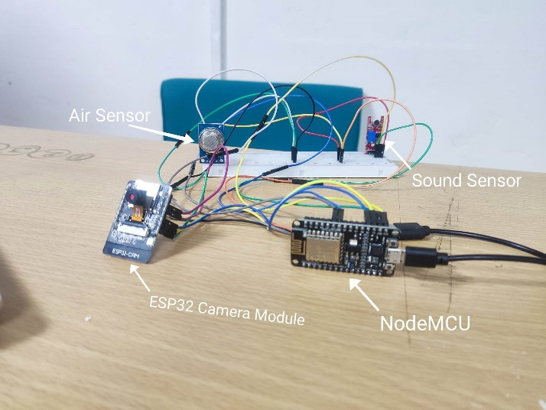

1. The internal of the proposed system

Once the sensors are set up, we will connect Micro USB Cable with the NodeMCU, and then run the code to get the desired result.

The entire hardware setup is placed inside a box designed with PVC board, and then the camera and all the sensors are set up with the box in such a way that all the important parts that are required in this demonstration is visible.

When the code is executed, the built-in LEDs in the gas sensor and sound sensor light up. The NodeMCU LED also lights up. This indicates that the power is turned on. When the system is plugged in the device such as PC or laptop, the codes are uploaded in Arduino IDE and run. Then we move to the ThinkSpeak website and the data collected are previewed in the form of a graphical method.

1. Results and Discussion

The final product is a box made with PVC board with a knob on the door. This knob is used to open and check the internal circuitry of the system. This has an IOT based system which is connected with the admin’s device.

The result shows the live feed from the camera module as expected, and there is no time delay. As for the gas and sound sensor, there is a very short time delay but the results in graphical method show the change in air quality as well as the sound quality, which was also expected from this project.

Table I and II shows the entries that were taken using the sensors. For the Sound sensor, the readings were taken every 0.05 seconds and then the values were put into table I. The maximum percentage reached for the sound sensor was 12.5%. As for the Gas sensor, the readings were taken every 10 seconds and the values were put into table II. The maximum percentage reached for the gas sensor was 37.8%. With this, we can conclude that there was just more than one-third gas pollution and just more than one-tenth air pollution.

1. Values observed from sound sensor

|  |  |
| --- | --- |
| Sound Level in % | Time in seconds |
| 0 | 0.00 |
| 12.5 | 0.05 |
| 11.2 | 0.10 |
| 12.2 | 0.15 |
| 12.2 | 0.20 |
| 11.1 | 0.25 |
| 12.2 | 0.30 |
| 11.4 | 0.35 |
| 11.2 | 0.40 |
| 11.2 | 0.45 |
| 11.2 | 0.50 |

1. Values observed from Gas sensor

|  |  |
| --- | --- |
| Gas Level in % | Time in seconds |
| 0 | 0.00 |
| 3.5 | 10.00 |
| 5.3 | 20.00 |
| 8.7 | 30.00 |
| 10.5 | 40.00 |
| 30.0 | 50.00 |
| 33.2 | 60.00 |
| 34.3 | 70.00 |
| 35.2 | 80.00 |
| 36.3 | 90.00 |
| 37.8 | 100.00 |

Fig. 10 and Fig 11 shows the output of the demonstration. The sound sensor graph shows fluctuations which indicate that there is no constant noise in the surroundings. The actual readings of the sound sensor were taken when the sensor was surrounding a crowded place filled with people. As for the gas sensor, the readings were taken when a spark was created from a lighter for a moment. But then it was kept at a closed place for some time, for which we can see a decrease in gas level over time.

The Camera Module does not have any table because it only shows us the live feed. The Camera Module must be connected with the NodeMCU, otherwise it won’t be able to display the live feed. We will connect the hotspot from the device with the NodeMCU so that we can run the code in Arduino IDE.

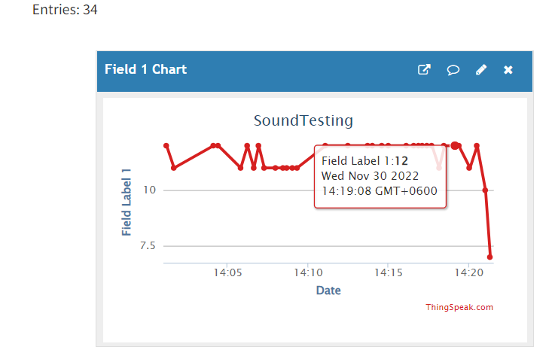

1. The graph for the Sound Sensor Module

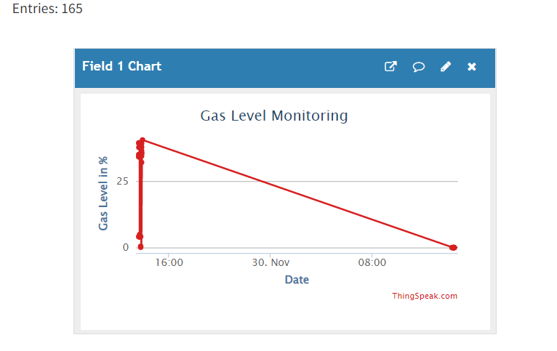

1. The graph for the Gas Sensor Module

One of the difficulties faced in this experiment was the sensitiveness of the components. The ESP32 Camera Module is smaller in size and the lens part is quite delicate. In addition, the lens has to be wiped every now and then. Another difficulty was the use of jumper wires with NodeMCU. The jumper wires connected with the ground pin got loose, incompletes the circuit and thus burned up the component. So, we must ensure that all the connections are made perfectly, otherwise the internal system will be damaged.

The overall cost of this project is very low according to the functionality of the project design. This device can be used for monitoring the traffic and study it more efficiently and this system also has room for updating with additional features.

1. Conclusions

The NodeMCU module is the central controller of this project which is able to connect all the components together with IoT and give accurate results. It has a very easy manual which can be used to set it up with other components.

The mechanism is not much expensive since few components are required in this experiment. The design of the system is also quite attracting and eye-catching. The system is very accurate and gives reliable results very rapidly. The system also has room for improvements, so changes can be made in order to make the system more efficient.

References

1. Traffic Management System Using IoT Technology - A Comparative Review. Accessed October 21, 2018
2. IoT for Intelligent Traffic Management. Accessed August 29, 2019.
3. An Intelligent Traffic Load Prediction-Based Adaptive Channel Assignment Algorithm in SDN-IoT: A Deep Learning Approach. Accessed May 21, 2018.
4. Design of Intelligent Bus Positioning Based on Internet of Things for Smart Campus. Accessed October 05, 2018.
5. A New Framework of Intelligent Public Transportation System Based on the Internet of Things. Accessed May 01, 2019.
6. Smart Traffic Management System Using Internet of Things. Accessed May 07, 2018.
7. Intelligent Traffic Control System Based on Cloud Computing and Big Data Mining. Accessed July 17, 2019.
8. Intelligent Traffic Control System Based on IoT. Accessed August 7, 2020.
9. Research on Urban Traffic Guidance System Based on Internet of Thing. Accessed November 11, 2018.
10. The Construction of Smart City Information System Based on the Internet of Things and Cloud Computing. Accessed on November 11, 2021.